**Assgn : 5.1(a)**

**baseRel = LOAD '/home/acadgild/hadoop/employee_details.txt' USING PigStorage(',') AS (empId:int,empName:chararray,empSal:chararray,empRating:int);**

**selRel = FOREACH baseRel GENERATE empId,empName, empRating;**

**filRel = ORDER selRel BY empRating DESC, empName ASC;**

**resRel = LIMIT filRel 5;**

**STORE resRel INTO '/home/acadgild/hadoop/maxRating' USING PigStorage(',');**

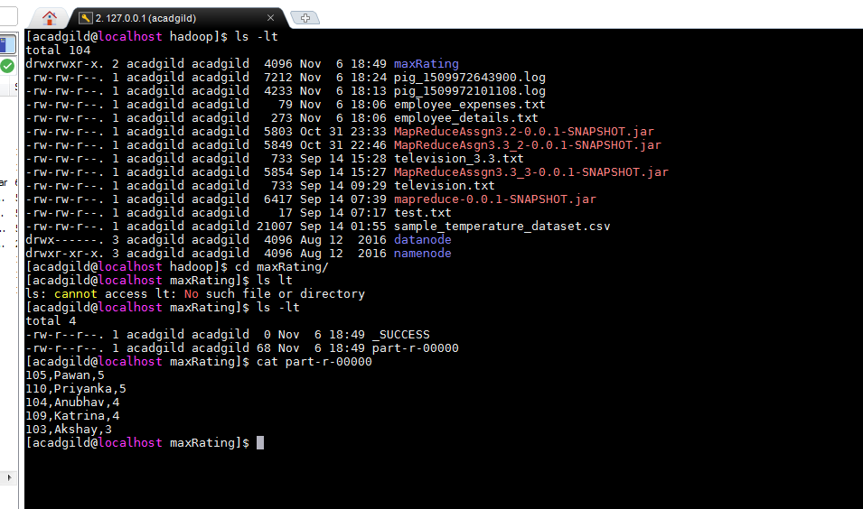

**Assgn : 5.1(c)**

**emp = LOAD '/home/acadgild/hadoop/employee_details.txt' USING PigStorage(',') AS (empId:int,empName:chararray,empSal:chararray,empRating:int);**

**emp_expenses = LOAD '/home/acadgild/hadoop/employee_expenses.txt' AS (empId:int,empExpenses:chararray);**

**joined_data = join emp by empId , emp_expenses by empId;**

**selRel = FOREACH joined_data GENERATE emp::empId,emp::empName,emp_expenses::empExpenses;**

**filRel = ORDER selRel BY emp_expenses::empExpenses DESC, emp::empName ASC;**

**resRel = LIMIT filRel 1;**

**STORE resRel INTO '/home/acadgild/hadoop/maxExpense' USING PigStorage(',');**

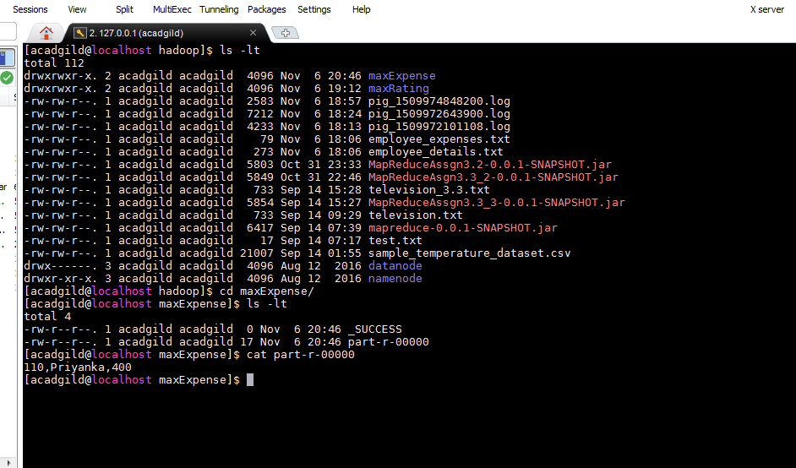

**Assgn : 5.1(d)**

**emp = LOAD '/home/acadgild/hadoop/employee_details.txt' USING PigStorage(',') AS (empId:int,empName:chararray,empSal:chararray,empRating:int);**

**emp_expenses = LOAD '/home/acadgild/hadoop/employee_expenses.txt' AS (empId:int,empExpenses:chararray);**

**right_joined_data = join emp by empId right, emp_expenses by empId;**

**selRel = FOREACH right_joined_data GENERATE emp::empId,emp::empName;**

**uniqueRel = DISTINCT selRel;**

**STORE uniqueRel INTO '/home/acadgild/hadoop/rightEmployees' USING PigStorage(',');**

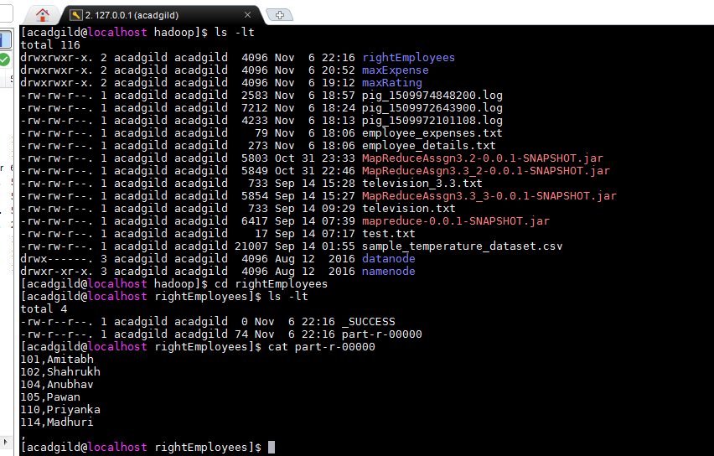

**Assgn : 5.1(e)**

**emp = LOAD '/home/acadgild/hadoop/employee_details.txt' USING PigStorage(',') AS (empId:int,empName:chararray,empSal:chararray,empRating:int);**

**emp_expenses = LOAD '/home/acadgild/hadoop/employee_expenses.txt' AS (empId:int,empExpenses:chararray);**

**left_joined_data = join emp by empId left outer, emp_expenses by empId;**

**empRel = FILTER left_joined_data BY emp_expenses::empId is null;**

**selRel = FOREACH empRel GENERATE emp::empId,emp::empName;**

**STORE selRel INTO '/home/acadgild/hadoop/EmployeesWIthNoExpenses' USING PigStorage(',');**

